Managing Products of Conception (POC)

< 20 Weeks

\*\****To be used if a fetus or products of conception (POC) is delivered in or brought to the Emergency Department.***

**1**

Patient Care Considerations:

* + Mirror the patient’s language when referring to the fetal remains  
    *(e.g. if they use a specific name or the term “baby”, use the same language).*Avoid medical jargon.
  + Apply butterfly sign to door as a sensitivity reminder to staff, and ensure all professionals coming into contact with the patient understand this symbol
  + Ask the patient if they would like to see, hold, and/or take photos of the fetus
  + Offer the patient a memory keepsake, based on hospital and local resources
    - Consider connecting with your birthing unit or L&D department for more resources
  + Offer to connect the family with cultural or spiritual leader to ensure traditions and customs can be observed
  + Know your hospital policy and be well-informed on patient choice related to POC disposition process  
    *(e.g., hospital or private disposition, and process for retrieval of fetal remains)*
  + Manage/package POC as per your hospital policy  
    *(suggested flowsheet below)*
    - Fetus may need to be weighed if later gestation age to determine  
      if it is a stillbirth; review your hospital policy
  + Provide patient and/or family with copies of paperwork as required
  + If the patient is taking fetal remains home, carefully consider how the remains will be packaged and presented to the patient

**NURSING CARE CHECKLIST**

NOTES:

Managing Products of Conception (POC)

< 20 Weeks

**2**

***\*\*To print to a PDF, select “Save as PDF” from your printer list choice and save to your documents\*\****

**Management, Packaging, and Transportation**

**of POC Flowsheet:**

\*\****Following your hospital guidelines for POC disposition, create a flowsheet to guide staff.***

***Example shown below (you can create your own and delete the example).***

**\*\*SAMPLE - create your own flowsheet based on your hospital policy and procedure\*\***

**Ensure patient and family understand their options related to disposition of products of conception, and clearly explain process for retrieval of fetal remains if applicable.**

Packaging of Fetal Remains:

1. Carefully place any fetal remains, products of conception, or tissue in a biohazard bag as shown.
2. Write date, time, and your signature on the label, and affix label to biohazard bag.
3. Place biohazard bag into infant shroud as shown.
4. Write date, time, and your signature on the second label, and affix second label to infant shroud.
5. Complete hospital-specific form for pathology and/or fetal testing. Include copies of form as per hospital policy. Ensure patient and/or family have copies of paperwork as required.
6. Call porter to transport infant shroud to morgue.

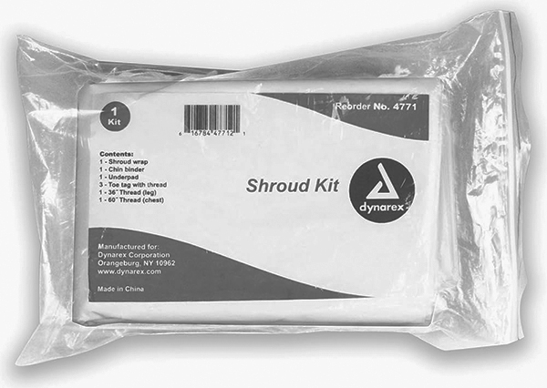

**Infant Shroud**

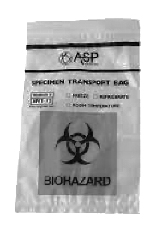

**Biohazard Bag**

**Fetal Remains** (Products of Conception)

CREATE / APPLY

LABEL

CREATE / APPLY

LABEL

Managing Products of Conception (POC)

< 20 Weeks

**3**

Upon Discharge for Complete Miscarriage:

* + Give the “Early Pregnancy Loss Patient Information Package” and review with the patient
  + Discuss warning signs to return to ED:
    - *Severe abdominal pain unrelieved by analgesia*
    - *Syncope or presyncope*
    - *Very heavy vaginal bleeding (soaking more than 3 pads in 3 hours)*
    - *Fever, chills*
    - *Foul smelling vaginal discharge*
  + Advocate for a work note
  + Advocate for analgesia prescription
  + Consider offering a referral to ED social worker, with patient consent
  + Consider offering a referral to the PAIL Network, with patient consent
    - Health care provider can refer or the patient can self-refer  
      [*https://pailnetwork.sunnybrook.ca/healthcare-professionals/referral/*](https://pailnetwork.sunnybrook.ca/healthcare-professionals/referral/)
  + Encourage to follow up with primary care provider
  + Make sure all applicable referrals are made and patient has the information  
    *(such as referral to a local early pregnancy evaluation clinic, if applicable*)

NOTES:

***\*\*To print to a PDF, select “Save as PDF” from your printer list choice and save to your documents\*\****