Patient Care Considerations:
  - Mirror the patient’s language when referring to the fetal remains
(e.g. if they use a specific name or the term “baby,” use the same language). Avoid medical jargon such as “products of conception” - consider saying “pregnancy tissues” instead.
  - Treat fetal remains with respect, handling them gently and with dignity, presenting remains to families with compassion and consideration of how this presentation

will be received:
    - Use a soft item to wrap remains (blanket, towel, gauze, etc.)
    - Avoid medical containers (emesis basins, buckets, bedpans, etc.)
  - Ask the patient if they would like to see, hold, and/or take photos of the baby
  - Offer the patient a memory keepsake, based on hospital and local resources
    - Consider connecting with your birthing unit or L&D department
for more resources
  - Apply butterfly sign to patient’s door/curtain as a sensitivity reminder to staff,
and ensure all staff coming into contact with the patient understand this symbol.
  - Offer to connect the family with cultural or spiritual leaders to ensure traditions and customs can be observed. Consider that some customs may require the complete placental and fetal remains to be returned to them.
  - Provide patient with an “Early Pregnancy Loss Patient Information Package”

Managing Products of Conception (POC):
- Determine whether this is a stillbirth or a miscarriage
    - Obtain a weight of fetal remains if necessary (if likely to be > 500g)
    - Stillbirth = > 20 weeks gestation OR > 500g (requires a death certificate, remains need to be managed through a funeral home)
    - Miscarriage (POC) = < 20 weeks gestation AND < 500g (no death certificate,
remains may be managed through hospital, funeral home, or privately)

Managing Products of Conception

(POC) < 20 weeks
To be used if a fetus or products of conception (POC) is delivered in or brought to the hospital.

1

PROVIDER CHECKLIST

Managing POC continued:

- Discuss POC arrangement options with patient:
    - Sample provider script: “I’m sorry for your loss. Every family has the right to choose how their baby’s remains are cared for. This is a personal choice, and we will support you in your decision.”

- Give patient the “Caring for your Miscarriage/Baby’s Remains in Hospital” and review with them
    - For hospital arrangements:
      - If your hospital has a specific ceremony for fetal remains, communicate the
information about this to the patient
      - See graphic below for hospital-specific guidelines for POC packaging
    - For private arrangements after pathology testing:
      - Ensure the patient knows the wait time (weeks/days) for retrieving their fetal
remains from pathology and the process of retrieval
      - See graphic below for hospital-specific guidelines for POC packaging
    - For private arrangements - same day:
      - Patient needs to sign a hospital specific “Release of Fetal Remains Form”,
taking responsibility for the remains and releasing the right to pathology testing. Consider making this similar to the form someone would sign to take home their placenta.
      - Carefully consider how the remains will be packaged and presented
to the patient
    - If the patient is undecided on arrangements before leaving the hospital, select private arrangements after pathology testing and inform the patient of the process to retrieve remains from the hospital if they choose to do so.
- Provide patient and/or family with copies of paperwork as required

Managing Products of Conception

(POC) < 20 weeks

2
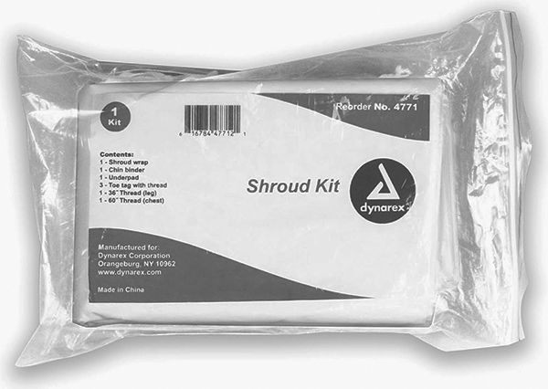
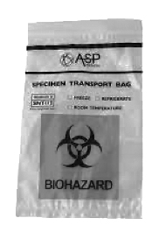

Packaging and Transportation of POC Flowsheet:

Following your hospital guidelines for POC disposition, create a flowsheet to guide staff. Replace this example with your own flowsheet.
**SAMPLE - create your own flowsheet based on your hospital policy and procedure**
Ensure patient and family understand their options related to disposition of products of conception, and clearly explain process for retrieval of fetal remains if applicable.

Packaging of Fetal Remains:

- Carefully place any fetal remains, products of conception, or tissue in a biohazard bag as shown.
- Write date, time, and your signature on the label, and affix label to biohazard bag.
- Place biohazard bag into infant shroud as shown.
- Write date, time, and your signature on the second label, and affix second label to infant shroud.
- Complete hospital-specific form for pathology and/or fetal testing. Include copies of form as per hospital policy. Ensure patient and/or family have copies of paperwork as required.
- Call porter to transport infant shroud to morgue.

Infant Shroud

Biohazard Bag

Fetal Remains (Products of Conception)

CREATE / APPLY

LABEL

CREATE / APPLY

LABEL

Managing Products of Conception

(POC) < 20 weeks

3

NOTES:

